**Agenda**

* *What was done*
  + Go around the room
  + 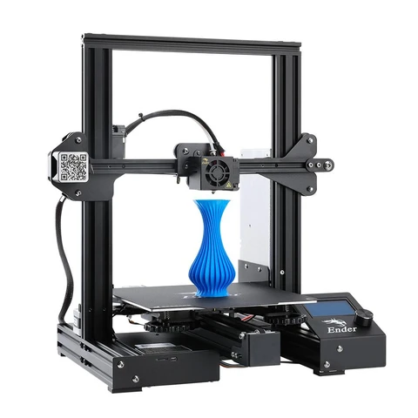
  + 3D printing repairs on bones - published work
    - Honey comb design proven to be working
  + 3D tissue repair
    - have data for different size holes
  + Why this is better
    - Cold spray & Direct energy deposition (DED)
      * Elaborates on aerospace 3D printing advantages
      * Add numbers and figures (citations!)
  + Reusing University of Hamburg toolpathing to avoid collisions
  + USC have done printing on concave and convex surfaces (Please add to the overall document!)
* [*Go over timeline*](https://docs.google.com/spreadsheets/d/1aGAjy4atVZg3dV3z4_LjOrD6C5V0l9KW2UKZrM0WlVs/edit#gid=0)
  + Let’s get everything setup and tested so we can start data collection soon.
  + Refer to the timeline to see if you can contribute to anything
* What needs to be done for presentation
  + People working on that should organize a later time to get that done if it’s not
* Who will present it?
  + Rohith - Lit review
  + Aidan - Methodology
* What has to be done after:
  + Printer development (blocked)
    - Order printer
  + Sample spec development
    - Research
      * Sample types and design criteria (defend a design to be repairing)
  + Software
    - Assess open source packages
* Need phone numbers: